UNITED STATES
SECURITIES AND EXCHANGE COMMISSION
Washington, D.C. 20549
FORM 8-K
CURRENT REPORT
Pursuant to Section 13 or 15(d) of the Securities Exchange Act of 1934
Date of Report (Date of earliest event reported): August 6, 2026
COLLEGIUM PHARMACEUTICAL, INC.
(Exact name of registrant as specified in its charter)
Virginia |  |  | 001-37372 |  |  | 03-0416362
(State or other jurisdiction of incorporation) |  |  | (Commission File Number) |  |  | (IRS Employer Identification No.)
 |  |  | 100 Technology Center Drive
 |  |  | Suite 300
 |  |  | Stoughton, MA 02072
 |  |  | (Address of principal executive offices) (Zip Code)
Registrant’s telephone number, including area code: (781) 713-3699
(Former name or former address, if changed since last report.)
Check the appropriate box below if the Form 8-K filing is intended to simultaneously satisfy the filing obligation of the registrant under any of the following provisions (see General Instruction A.2. below):
☐ |  |  | Written communications pursuant to Rule 425 under the Securities Act (17 CFR 230.425)
☐ |  |  | Soliciting material pursuant to Rule 14a-12 under the Exchange Act (17 CFR 240.14a-12)
☐ |  |  | Pre-commencement communications pursuant to Rule 14d-2(b) under the Exchange Act (17 CFR 240.14d-2(b))
☐ |  |  | Pre-commencement communications pursuant to Rule 13e-4(c) under the Exchange Act (17 CFR 240.13e-4(c))
Securities registered pursuant to Section 12(b) of the Act:
Title of each class |  |  | Trading Symbol(s) |  |  | Name of each exchange on which registered
Common stock, par value $0.001 per share |  |  | COLL |  |  | The NASDAQ Global Select Market
Indicate by check mark whether the registrant is an emerging growth company as defined in Rule 405 of the Securities Act of 1933 (§230.405 of this chapter) or Rule 12b-2 of the Securities Exchange Act of 1934 (§240.12b-2 of this chapter).
Emerging growth company ☐
If an emerging growth company, indicate by check mark if the registrant has elected not to use the extended transition period for complying with any new or revised financial accounting standards provided pursuant to Section 13(a) of the Exchange Act. ☐

Item 2.02 Results of Operations and Financial Condition.
On August 6, 2026, Collegium Pharmaceutical, Inc. (the “Company”) issued a press release announcing its financial results for the quarterly period ended June 30, 2026. The full text of the press release issued in connection with the announcement is attached hereto as Exhibit 99.1 and is being furnished, not filed, under Item 2.02 of this Current Report on Form 8-K.

Item 7.01 Regulation FD Disclosure.
On August 6, 2026, Collegium Pharmaceutical, Inc. released an earnings presentation. The presentation is attached hereto as Exhibit 99.2 and is being furnished, not filed, under Item 7.01 of this Current Report on Form 8-K.

Item 9.01 Financial Statements and Exhibits.
(d)Exhibits
EXHIBIT TABLE

Exhibit  No. |  |  |  |  |  | Description
99.1 |  |  |  |  |  | Press Release, dated August 6, 2026
99.2 |  |  |  |  |  | Earnings Presentation, dated August 6, 2026
104 |  |  |  |  |  | Cover Page Interactive Data File (embedded within the Inline XBRL document)

SIGNATURES
Pursuant to the requirements of the Securities Exchange Act of 1934, the registrant has duly caused this report to be signed on its behalf by the undersigned hereunto duly authorized.
 |  |  | Collegium Pharmaceutical, Inc.
 |  |  | By: |  |  | /s/ Colleen Tupper
 |  |  |  |  |  | Colleen Tupper
 |  |  |  |  |  | Executive Vice President and Chief Financial Officer
Dated: August 6, 2026

Exhibit 99.1

Collegium Reports Second Quarter 2026 Financial Results and Highlights Recent Company Progress

– Completed Acquisition of AZSTARYS®, Strengthening ADHD Portfolio and Extending Long-Term Revenue Outlook –

– Generated Quarterly Net Revenues of $199.9 Million, Up 6% Year-over-Year –

– Generated JORNAY PM® Quarterly Net Revenue of $46.1 Million, Up 41% Year-over-Year –

– Generated AZSTARYS Quarterly Net Revenue of $12.9 Million, Representing a Partial Quarter of Sales –

– Generated Quarterly Pain Portfolio Net Revenues of $140.9 Million –

– Updates Full-Year 2026 Financial Guidance –

– Conference Call Scheduled for Today at 8:00 a.m. ET –

STOUGHTON, Mass., August 6, 2026 -- Collegium Pharmaceutical, Inc. (Nasdaq: COLL), a leading biopharmaceutical company focused on improving the lives of people living with serious and often misunderstood conditions, today reported its financial results for the quarter ended June 30, 2026, and provided a business update.

“In the second quarter, we saw strong demand across our ADHD portfolio, highlighted by record-high JORNAY PM prescriptions and prescriber adoption, alongside 41% revenue growth. Importantly, we have completed the acquisition of AZSTARYS and our integration is progressing well, with our expanded salesforce fully trained and deployed ahead of the important back-to-school season,” said Vikram Karnani, President and Chief Executive Officer. “In addition, our pain portfolio continues to provide a solid base for our business despite increased pressure on Nucynta franchise revenues. Together, our differentiated ADHD portfolio and established pain business provide a strong foundation for growth and long-term value creation. As we move into the second half of the year, we are focused on three key strategic priorities: driving growth in our ADHD business, maximizing the value of our pain portfolio, and strategically deploying capital to create long-term shareholder value."

"During the quarter, we delivered solid performance across our business, successfully integrated AZSTARYS and generated robust operating cash flows," said Colleen Tupper, Chief Financial Officer. "As we enter the back-to-school season, our organization is well positioned with two differentiated and complementary ADHD medicines and supported by a single commercial platform that enhances our ability to serve healthcare providers and patients, alike.”

ADHD Business Highlights

•Generated JORNAY PM net revenue of $46.1 million, up 41% year-over-year in the in the quarter ended June 30, 2026 (the 2026 Quarter).
•JORNAY PM prescribers reached an all-time high in the 2026 Quarter with over 30,000 healthcare providers writing JORNAY PM prescriptions, up 17.6% year-over-year.
•Grew JORNAY PM prescriptions 13.1% year over year in the 2026 Quarter.
•In May, completed the acquisition of AZSTARYS from Corium Therapeutics. The acquisition adds a highly complementary and differentiated ADHD medicine with significant growth potential and expected patent protection through 2037.
•Generated $12.9 million in AZSTARYS net revenue from May 12, 2026, to June 30, 2026, following the acquisition close.
•AZSTARYS prescriptions grew 1.9% in the 2026 Quarter compared to the quarter ended June 30, 2025 (the 2025) Quarter.
•In May, reinforced commitment to scientific research through published studies and poster presentations at leading medical conferences highlighting real-world data for JORNAY PM and AZSTARYS.

Pain Portfolio Highlights

•Generated pain portfolio net revenues of $140.9 million in the 2026 Quarter, down 9% year-over-year.
•Generated Belbuca® net revenue of $57.7 million in the 2026 Quarter, up 10% year-over-year.
•Generated Xtampza® ER net revenue of $45.0 million in the 2026 Quarter, down 14% year-over-year.
•Generated Nucynta Franchise net revenue of $35.2 million in the 2026 Quarter, down 24% year-over-year. This included $5.1 million from the sale of the authorized generic (AG) versions of Nucynta and Nucynta ER.

Corporate Updates

•In July, announced plans to relocate its corporate headquarters to downtown Boston in the first quarter of 2027.
•In June, recognized by the Boston Business Journal as one of the 2026 Best Places to Work in Massachusetts and named a USA Today Top Workplace for 2026.
•In May, strengthened its Board of Directors with the appointment of Michael Donovan, former senior audit partner at Ernst and Young (EY).

Upcoming Events

The Company will participate in the following upcoming investor conferences in the third quarter of 2026:

•Citi 2026 Biopharma Back to School Conference – New York, NY; September 9, 2026
•Morgan Stanley 24th Annual Global Healthcare Conference – New York, NY; September 15, 2026
•H.C. Wainwright 28th Annual Global Investment Conference – New York, NY; September 16, 2026

Financial Guidance for 2026

Collegium reaffirms its full-year 2026 guidance for JORNAY PM and raises AZSTARYS Revenue, Net and updates its full-year 2026 guidance for Product Revenues, Net, and Adjusted EBITDA. The decreases in Product Revenues, Net and Adjusted EBITDA are largely driven by lower-than-expected revenue from the AG versions of Nucynta and Nucynta ER due to lower net pricing.

 |  |  | Prior |  |  | Updated
Product Revenues, Net |  |  | $865 to $895 million |  |  | $825 to $855 million
JORNAY PM Revenue, Net |  |  | $190 to $200 million |  |  | Unchanged
AZSTARYS Revenue, Net |  |  | $60 to $70 million |  |  | $65 to $75 million
Adjusted EBITDA |  |  | $475 to $500 million |  |  | $445 to $470 million

Financial Results for Quarter Ended June 30, 2026

•Product revenues, net were $199.9 million for the 2026 Quarter, compared to $188.0 million for the quarter ended June 30, 2025 (the 2025 Quarter), representing a 6% increase year-over-year.
•GAAP operating expenses were $106.6 million for the 2026 Quarter, compared to $73.3 million for the 2025 Quarter, representing a 45% increase year-over-year. Adjusted operating expenses, which exclude stock-based compensation expense and acquisition related expenses were $66.6 million for the 2026 Quarter, compared to $61.9 million for the 2025 Quarter, representing an 8% increase year-over-year.
•GAAP net loss for the 2026 Quarter was ($15.1) million, with ($0.46) GAAP loss per share (basic) and ($0.46) GAAP loss per share (diluted), compared to GAAP net income for the 2025 Quarter of $12.0 million, with $0.38 GAAP earnings per share (basic) and $0.34 GAAP earnings per share (diluted). Non-GAAP adjusted net income

for the 2026 Quarter was $75.4 million, with $1.92 adjusted earnings per share, compared to non-GAAP adjusted net income for the 2025 Quarter of $64.3 million, with $1.68 adjusted earnings per share.
•Adjusted EBITDA for the 2026 Quarter was $113.8 million, compared to $105.1 million for the 2025 Quarter, representing an 8% increase year-over-year.
•The Company generated $71.3 million in cash from operations, and exited the 2026 Quarter with cash, cash equivalents and marketable securities of $129.5 million.

Conference Call Information

The Company will host a conference call and live audio webcast on Thursday, August 6, 2026, at 8:00 a.m. ET. To access the conference call, please dial (877) 407-8037 (U.S.) or (201) 689-8037 (International) and reference the “Collegium Pharmaceutical Second Quarter 2026 Earnings Call.” An audio webcast will be accessible from the Investors section of the Company’s website: www.collegiumpharma.com. The webcast will be available for replay on the Company’s website approximately two hours after the event.

About Collegium Pharmaceutical, Inc.

Collegium Pharmaceutical is a dynamic, biopharmaceutical company delivering medicines with formulation and delivery innovation for people living with complex central nervous system and pain conditions. Collegium has spent more than a decade proving that responsible stewardship and bold, science-backed approaches can redefine what treatment looks like in categories too often shaped by complexity and misconceptions.

With a portfolio of differentiated ADHD medications, anchored by JORNAY PM® (methylphenidate HCl) and AZSTARYS® (serdexmethylphenidate and dexmethylphenidate), and an established leadership position in responsible pain management, Collegium leads with the scientific rigor and commercial expertise to deliver treatment options around how people live their lives. For more information, please visit collegiumpharma.com or find us on LinkedIn.

Non-GAAP Financial Measures

To supplement our financial results presented on a GAAP basis, we have included information about certain non-GAAP financial measures. We believe the presentation of these non-GAAP financial measures, when viewed with our results under GAAP and the accompanying reconciliations, provide analysts, investors, lenders, and other third parties with insights into how we evaluate normal operational activities, including our ability to generate cash from operations, on a comparable year-over-year basis and manage our budgeting and forecasting. In addition, certain non-GAAP financial measures, primarily adjusted EBITDA, are used to measure performance when determining components of annual compensation for substantially all non-sales force employees, including senior management.

In this press release we discuss the following financial measures that are not calculated in accordance with GAAP.

Adjusted EBITDA

Adjusted EBITDA is a non-GAAP financial measure that represents GAAP net income or loss adjusted to exclude interest expense, interest income, the benefit from or provision for income taxes, depreciation, amortization, stock-based compensation, and other adjustments to reflect changes that occur in our business but do not represent ongoing operations. Adjusted EBITDA, as used by us, may be calculated differently from, and therefore may not be comparable to, similarly titled measures used by other companies.

There are several limitations related to the use of adjusted EBITDA rather than net income or loss, which is the nearest GAAP equivalent, such as:

•adjusted EBITDA excludes depreciation and amortization, and, although these are non-cash expenses, the assets being depreciated or amortized may have to be replaced in the future, the cash requirements for which are not reflected in adjusted EBITDA;
•adjusted EBITDA does not reflect changes in, or cash requirements for, working capital needs;
•adjusted EBITDA does not reflect the benefit from or provision for income taxes or the cash requirements to pay taxes;
•adjusted EBITDA does not reflect historical cash expenditures or future requirements for capital expenditures or contractual commitments;
•we exclude stock-based compensation expense from adjusted EBITDA although: (i) it has been, and will continue to be for the foreseeable future, a significant recurring expense for our business and an important part of our compensation strategy; and (ii) if we did not pay out a portion of our compensation in the form of stock-based

compensation, the cash salary expense included in operating expenses would be higher, which would affect our cash position;
•we exclude impairment expenses from adjusted EBITDA and, although these are non-cash expenses, the asset(s) being impaired may have to be replaced in the future, the cash requirements for which are not reflected in adjusted EBITDA;
•we exclude restructuring expenses from adjusted EBITDA. Restructuring expenses primarily include employee severance and contract termination costs that are not related to acquisitions. The amount and/or frequency of these restructuring expenses are not part of our underlying business;
•we exclude litigation settlements and contingencies that are subject to recovery from adjusted EBITDA, as well as any applicable income items, credit adjustments, or recoveries due to subsequent changes in estimates. This does not include our legal fees to defend claims, which are expensed as incurred;
•we exclude acquisition-related expenses as these expenses would not have otherwise been incurred in the periods presented as part of our continuing operations and their exclusion is useful to investors because it enhances comparability of operating performance across periods. Acquisition-related expenses include transaction costs, which primarily consisted of financial advisory, banking, legal, and regulatory fees, and other consulting fees, incurred to complete the acquisition, employee-related expenses (severance cost and benefits) for terminated employees after the acquisition, legal defense expenses for specific acquired claims that relate to acts that occurred prior to our acquisition, and miscellaneous other acquisition-related expenses incurred;
•we exclude recognition of the step-up basis in inventory from acquisitions (i.e., the adjustment to record inventory from historic cost to fair value at acquisition) as the adjustment does not reflect the ongoing expense associated with sale of our products as part of our underlying business;
•we exclude changes in the fair value of contingent consideration, which are non-cash, acquisition-related items that are not part of our underlying business;
•we exclude losses on extinguishments of debt as these expenses are episodic in nature and do not directly correlate to the cost of operating our business on an ongoing basis;
•we exclude executive transition expenses from adjusted EBITDA as the amount and/or frequency of these expenses are episodic in nature and do not directly correlate to the cost of operating our business on an ongoing basis; and
•we exclude other expenses, from time to time, that are episodic in nature and do not directly correlate to the cost of operating our business on an ongoing basis.

The Company has not provided a reconciliation of its full-year 2026 guidance for adjusted EBITDA to the most directly comparable forward-looking GAAP measures, in reliance on the unreasonable efforts exception provided under Item 10(e)(1)(i)(B) of Regulation S-K, because the Company is unable to predict, without unreasonable efforts, the timing and amount of items that would be included in such a reconciliation, including, but not limited to, stock-based compensation expense, acquisition related expenses, amortization of acquired intangible assets, and changes in fair value of contingent consideration. These items are uncertain and depend on various factors that are outside of the Company’s control or cannot be reasonably predicted. While the Company is unable to address the probable significance of these items, they could have a material impact on GAAP net income and operating expenses for the guidance period. A reconciliation of adjusted EBITDA would imply a degree of precision and certainty as to these future items that does not exist and could be confusing to investors.

Forward-Looking Statements

This press release contains forward-looking statements within the meaning of The Private Securities Litigation Reform Act of 1995. We may, in some cases, use terms such as "predicts," "forecasts," "believes," "potential," "proposed," "continue," "estimates," "anticipates," "expects," "plans," "intends," "may," "could," "might," "should" or other words that convey uncertainty of future events or outcomes to identify these forward-looking statements. Examples of forward-looking statements contained in this press release include, among others, projected financial performance, including expected revenue and adjusted EBITDA; statements related to the anticipated benefits of the acquisition of AZSTARYS, including its impact on Collegium’s ADHD portfolio and commercial strategy; statements related to current and future market opportunities for our products and our assumptions related thereto and other statements that are not historic facts. Such statements are subject to numerous important factors, risks and uncertainties that may cause actual events or results, performance, or achievements to differ materially from the company's current expectations, including risks relating to, among others: our ability to realize the anticipated benefits of the AZSTARYS acquisition, including the possibility that the expected benefits from the acquisition will not be realized or will not be realized within the expected time period; the risk that the businesses will not be integrated successfully; significant transaction costs or the acquisition of unknown liabilities; future opportunities and plans for our products, including uncertainty of the expected financial performance of such products; our ability to commercialize and grow sales of our products; our ability to manage our relationships with licensors; the success of competing products that are or become available; our ability to maintain regulatory approval of our products, and any related restrictions, limitations, and/or warnings in the label of our products; the size of the markets for our products, and our ability to service those markets; our ability to obtain reimbursement and third-party payor contracts

for our products; the rate and degree of market acceptance of our products; the costs of commercialization activities, including marketing, sales and distribution; changing market conditions for our products; the outcome of any patent infringement or other litigation that may be brought by or against us; the outcome of any governmental investigation related to our business; our ability to secure adequate supplies of active pharmaceutical ingredient for each of our products and manufacture adequate supplies of commercially saleable inventory; our ability to obtain funding for our operations and business development; regulatory developments in the U.S.; our expectations regarding our ability to obtain and maintain sufficient intellectual property protection for our products; our ability to comply with stringent U.S. and foreign government regulation in the manufacture of pharmaceutical products, including U.S. Drug Enforcement Agency compliance; our customer concentration; and the accuracy of our estimates regarding expenses, revenues, capital requirements and need for additional financing. These and other risks are described under the heading "Risk Factors" in our Annual Reports on Form 10-K and Quarterly Reports on Form 10-Q and other filings with the SEC. Any forward-looking statements that we make in this press release speak only as of the date of this press release. We assume no obligation to update our forward-looking statements whether as a result of new information, future events or otherwise, after the date of this press release.

Investor Contact:
Ian Karp
Head of Investor Relations
ir@collegiumpharma.com

Media Contact:
Jessica Cotrone
Senior Vice President, Corporate Communications & Corporate Affairs
communications@collegiumpharma.com

Collegium Pharmaceutical, Inc.
Unaudited Selected Consolidated Balance Sheet Information
(in thousands)
 |  |  | June 30, |  |  |  |  |  | December 31,
 |  |  | 2026 |  |  |  |  |  | 2025
Cash and cash equivalents |  |  | $ | 129,467 |  |  |  |  | $ | 231,252
Marketable securities |  |  | — |  |  |  |  |  | 155,427
Accounts receivable, net |  |  | 285,102 |  |  |  |  |  | 211,328
Inventory |  |  | 113,269 |  |  |  |  |  | 40,912
Prepaid expenses and other current assets |  |  | 60,326 |  |  |  |  |  | 32,642
Property and equipment, net |  |  | 10,653 |  |  |  |  |  | 12,013
Operating lease assets |  |  | 3,791 |  |  |  |  |  | 4,187
Intangible assets, net |  |  | 1,186,084 |  |  |  |  |  | 669,510
Restricted cash |  |  | 20,910 |  |  |  |  |  | 20,906
Deferred tax assets |  |  | 120,774 |  |  |  |  |  | 112,539
Other noncurrent assets |  |  | 15,237 |  |  |  |  |  | 20,193
Goodwill |  |  | 190,177 |  |  |  |  |  | 145,925
Total assets |  |  | $ | 2,135,790 |  |  |  |  | $ | 1,656,834
Accounts payable and accrued liabilities |  |  | $ | 80,491 |  |  |  |  | $ | 73,123
Accrued rebates, returns and discounts |  |  | 406,854 |  |  |  |  |  | 318,266
Business combination consideration payable |  |  | 29,719 |  |  |  |  |  | 17,565
Term notes payable |  |  | 852,824 |  |  |  |  |  | 571,112
Convertible senior notes |  |  | 238,733 |  |  |  |  |  | 238,213
Operating lease liabilities |  |  | 4,968 |  |  |  |  |  | 5,539
Deferred royalty obligation |  |  | 121,357 |  |  |  |  |  | 121,563
Deferred revenue |  |  | 9,445 |  |  |  |  |  | 9,778
Contingent consideration |  |  | 38,525 |  |  |  |  |  | —
Deferred tax liabilities |  |  | 40,965 |  |  |  |  |  | —
Shareholders’ equity |  |  | 311,909 |  |  |  |  |  | 301,675
Total liabilities and shareholders’ equity |  |  | $ | 2,135,790 |  |  |  |  | $ | 1,656,834

Collegium Pharmaceutical, Inc.
Unaudited Condensed Statements of Operations
(in thousands, except share and per share amounts)
 |  |  | Three Months Ended June 30, |  |  |  |  |  |  |  |  |  |  |  | Six Months Ended June 30,
 |  |  | 2026 |  |  |  |  |  | 2025 |  |  |  |  |  | 2026 |  |  |  |  |  | 2025
Product revenues, net |  |  | $ | 199,878 |  |  |  |  | $ | 188,000 |  |  |  |  | $ | 393,398 |  |  |  |  | $ | 365,757
Cost of product revenues
Cost of product revenues (excluding intangible asset amortization) |  |  | 26,633 |  |  |  |  |  | 24,143 |  |  |  |  |  | 47,434 |  |  |  |  |  | 49,103
Intangible asset amortization |  |  | 62,953 |  |  |  |  |  | 55,473 |  |  |  |  |  | 118,426 |  |  |  |  |  | 110,946
Total cost of product revenues |  |  | 89,586 |  |  |  |  |  | 79,616 |  |  |  |  |  | 165,860 |  |  |  |  |  | 160,049
Gross profit |  |  | 110,292 |  |  |  |  |  | 108,384 |  |  |  |  |  | 227,538 |  |  |  |  |  | 205,708
Operating expenses
Selling, general and administrative |  |  | 106,594 |  |  |  |  |  | 73,637 |  |  |  |  |  | 192,944 |  |  |  |  |  | 150,060
Gain on fair value remeasurement of contingent consideration |  |  | — |  |  |  |  |  | (358) |  |  |  |  |  | — |  |  |  |  |  | (1,144)
Total operating expenses |  |  | 106,594 |  |  |  |  |  | 73,279 |  |  |  |  |  | 192,944 |  |  |  |  |  | 148,916
Income from operations |  |  | 3,698 |  |  |  |  |  | 35,105 |  |  |  |  |  | 34,594 |  |  |  |  |  | 56,792
Interest expense |  |  | (19,519) |  |  |  |  |  | (20,463) |  |  |  |  |  | (35,381) |  |  |  |  |  | (41,253)
Interest income |  |  | 2,289 |  |  |  |  |  | 2,383 |  |  |  |  |  | 5,995 |  |  |  |  |  | 4,608
(Loss) income before income taxes |  |  | (13,532) |  |  |  |  |  | 17,025 |  |  |  |  |  | 5,208 |  |  |  |  |  | 20,147
Provision for income taxes |  |  | 1,519 |  |  |  |  |  | 5,042 |  |  |  |  |  | 5,763 |  |  |  |  |  | 5,747
Net (loss) income |  |  | $ | (15,051) |  |  |  |  | $ | 11,983 |  |  |  |  | $ | (555) |  |  |  |  | $ | 14,400
(Loss) earnings per share — basic |  |  | $ | (0.46) |  |  |  |  | $ | 0.38 |  |  |  |  | $ | (0.02) |  |  |  |  | $ | 0.45
Weighted-average shares — basic |  |  | 32,460,783 |  |  |  |  |  | 31,810,612 |  |  |  |  |  | 32,275,159 |  |  |  |  |  | 31,802,222
(Loss) earnings per share — diluted |  |  | $ | (0.46) |  |  |  |  | $ | 0.34 |  |  |  |  | $ | (0.02) |  |  |  |  | $ | 0.44
Weighted-average shares — diluted |  |  | 32,460,783 |  |  |  |  |  | 39,075,703 |  |  |  |  |  | 32,275,159 |  |  |  |  |  | 39,283,297

Collegium Pharmaceutical, Inc.
Reconciliation of GAAP Net Income to Adjusted EBITDA
(in thousands)
(unaudited)
 |  |  | Three Months Ended June 30, |  |  |  |  |  |  |  |  |  |  |  | Six Months Ended June 30,
 |  |  | 2026 |  |  |  |  |  | 2025 |  |  |  |  |  | 2026 |  |  |  |  |  | 2025
GAAP net (loss) income |  |  | $ | (15,051) |  |  |  |  | $ | 11,983 |  |  |  |  | $ | (555) |  |  |  |  | $ | 14,400
Adjustments:
Interest expense |  |  | 19,519 |  |  |  |  |  | 20,463 |  |  |  |  |  | 35,381 |  |  |  |  |  | 41,253
Interest income |  |  | (2,289) |  |  |  |  |  | (2,383) |  |  |  |  |  | (5,995) |  |  |  |  |  | (4,608)
Provision for income taxes |  |  | 1,519 |  |  |  |  |  | 5,042 |  |  |  |  |  | 5,763 |  |  |  |  |  | 5,747
Depreciation |  |  | 1,812 |  |  |  |  |  | 1,135 |  |  |  |  |  | 2,275 |  |  |  |  |  | 2,226
Amortization |  |  | 62,953 |  |  |  |  |  | 55,473 |  |  |  |  |  | 118,426 |  |  |  |  |  | 110,946
Stock-based compensation |  |  | 14,484 |  |  |  |  |  | 10,818 |  |  |  |  |  | 25,364 |  |  |  |  |  | 22,342
Recognition of step-up basis in inventory |  |  | 5,417 |  |  |  |  |  | 1,954 |  |  |  |  |  | 5,417 |  |  |  |  |  | 5,431
Executive transition expense |  |  | 1,393 |  |  |  |  |  | — |  |  |  |  |  | 1,393 |  |  |  |  |  | 1,397
Acquisition-related expenses |  |  | 24,086 |  |  |  |  |  | 935 |  |  |  |  |  | 30,261 |  |  |  |  |  | 2,224
Gain on fair value remeasurement of contingent consideration |  |  | — |  |  |  |  |  | (358) |  |  |  |  |  | — |  |  |  |  |  | (1,144)
Total adjustments |  |  | $ | 128,894 |  |  |  |  | $ | 93,079 |  |  |  |  | $ | 218,285 |  |  |  |  | $ | 185,814
Adjusted EBITDA |  |  | $ | 113,843 |  |  |  |  | $ | 105,062 |  |  |  |  | $ | 217,730 |  |  |  |  | $ | 200,214

Collegium Pharmaceutical, Inc.
Reconciliation of GAAP Operating Expenses to Adjusted Operating Expenses
(in thousands)
(unaudited)

 |  |  | Three Months Ended June 30, |  |  |  |  |  |  |  |  |  |  |  | Six Months Ended June 30,
 |  |  | 2026 |  |  |  |  |  | 2025 |  |  |  |  |  | 2026 |  |  |  |  |  | 2025
GAAP operating expenses |  |  | $ | 106,594 |  |  |  |  | $ | 73,279 |  |  |  |  | $ | 192,944 |  |  |  |  | $ | 148,916
Adjustments:
Stock-based compensation |  |  | 14,484 |  |  |  |  |  | 10,818 |  |  |  |  |  | 25,364 |  |  |  |  |  | 22,342
Executive transition expense |  |  | 1,393 |  |  |  |  |  | — |  |  |  |  |  | 1,393 |  |  |  |  |  | 1,397
Acquisition-related expenses |  |  | 24,086 |  |  |  |  |  | 935 |  |  |  |  |  | 30,261 |  |  |  |  |  | 2,224
Gain on fair value remeasurement of contingent consideration |  |  | — |  |  |  |  |  | (358) |  |  |  |  |  | — |  |  |  |  |  | (1,144)
Total adjustments |  |  | $ | 39,963 |  |  |  |  | $ | 11,395 |  |  |  |  | $ | 57,018 |  |  |  |  | $ | 24,819
Adjusted operating expenses |  |  | $ | 66,631 |  |  |  |  | $ | 61,884 |  |  |  |  | $ | 135,926 |  |  |  |  | $ | 124,097

Collegium Pharmaceutical, Inc.
Reconciliation of GAAP Net Income to Adjusted Net Income and Adjusted Earnings Per Share
(in thousands, except share and per share amounts)
(unaudited)
 |  |  | Three Months Ended June 30, |  |  |  |  |  |  |  |  |  |  |  | Six Months Ended June 30,
 |  |  | 2026 |  |  |  |  |  | 2025 |  |  |  |  |  | 2026 |  |  |  |  |  | 2025
GAAP net (loss) income |  |  | $ | (15,051) |  |  |  |  | $ | 11,983 |  |  |  |  | $ | (555) |  |  |  |  | $ | 14,400
Adjustments:
Non-cash interest expense |  |  | 1,082 |  |  |  |  |  | 1,355 |  |  |  |  |  | 1,901 |  |  |  |  |  | 2,722
Amortization |  |  | 62,953 |  |  |  |  |  | 55,473 |  |  |  |  |  | 118,426 |  |  |  |  |  | 110,946
Stock-based compensation |  |  | 14,484 |  |  |  |  |  | 10,818 |  |  |  |  |  | 25,364 |  |  |  |  |  | 22,342
Recognition of step-up basis in inventory |  |  | 5,417 |  |  |  |  |  | 1,954 |  |  |  |  |  | 5,417 |  |  |  |  |  | 5,431
Executive transition expense |  |  | 1,393 |  |  |  |  |  | — |  |  |  |  |  | 1,393 |  |  |  |  |  | 1,397
Acquisition-related expenses |  |  | 24,086 |  |  |  |  |  | 935 |  |  |  |  |  | 30,261 |  |  |  |  |  | 2,224
Gain on fair value remeasurement of contingent consideration |  |  | — |  |  |  |  |  | (358) |  |  |  |  |  | — |  |  |  |  |  | (1,144)
Income tax effect of above adjustments (1) |  |  | (18,959) |  |  |  |  |  | (17,871) |  |  |  |  |  | (37,588) |  |  |  |  |  | (36,608)
Total adjustments |  |  | $ | 90,456 |  |  |  |  | $ | 52,306 |  |  |  |  | $ | 145,174 |  |  |  |  | $ | 107,310
Non-GAAP adjusted net income |  |  | $ | 75,405 |  |  |  |  | $ | 64,289 |  |  |  |  | $ | 144,619 |  |  |  |  | $ | 121,710
Adjusted weighted-average shares — diluted (2) |  |  | 39,935,892 |  |  |  |  |  | 39,075,703 |  |  |  |  |  | 40,076,322 |  |  |  |  |  | 39,283,297
Adjusted earnings per share (2) |  |  | $ | 1.92 |  |  |  |  | $ | 1.68 |  |  |  |  | $ | 3.67 |  |  |  |  | $ | 3.16
(1)The income tax effect of the adjustments was calculated by applying our blended federal and state statutory rate to the items that have a tax effect. The blended federal and state statutory rate for the three months ended June 30, 2026 and 2025 were 22.9% and 25.7%, respectively; and the blended federal and state statutory rate for the six months ended June 30, 2026 and 2025 were 23.6% and 25.8%, respectively. As such, the non-GAAP effective tax rates for the three months ended June 30, 2026 and 2025 were 17.3% and 25.5%, respectively; and the non-GAAP effective tax rates for the six months ended June 30, 2026 and 2025 were 20.6% and 25.4%, respectively.
(2)Adjusted weighted-average shares - diluted were calculated using the “if-converted” method for our convertible notes in accordance with ASC 260, Earnings per Share. As such, adjusted weighted-average shares – diluted includes shares related to the assumed conversion of our convertible notes and the associated cash interest expense is added-back to non-GAAP adjusted net income. For the three and six months ended June 30, 2026 and 2025, adjusted weighted-average shares – diluted includes 6,606,305 shares attributable to our convertible notes. In addition, adjusted earnings per share includes other potentially dilutive securities to the extent that they are not antidilutive.


Q2 2026 Earnings Report August 6, 2026 | Nasdaq: COLL Healthier people. Stronger communities.

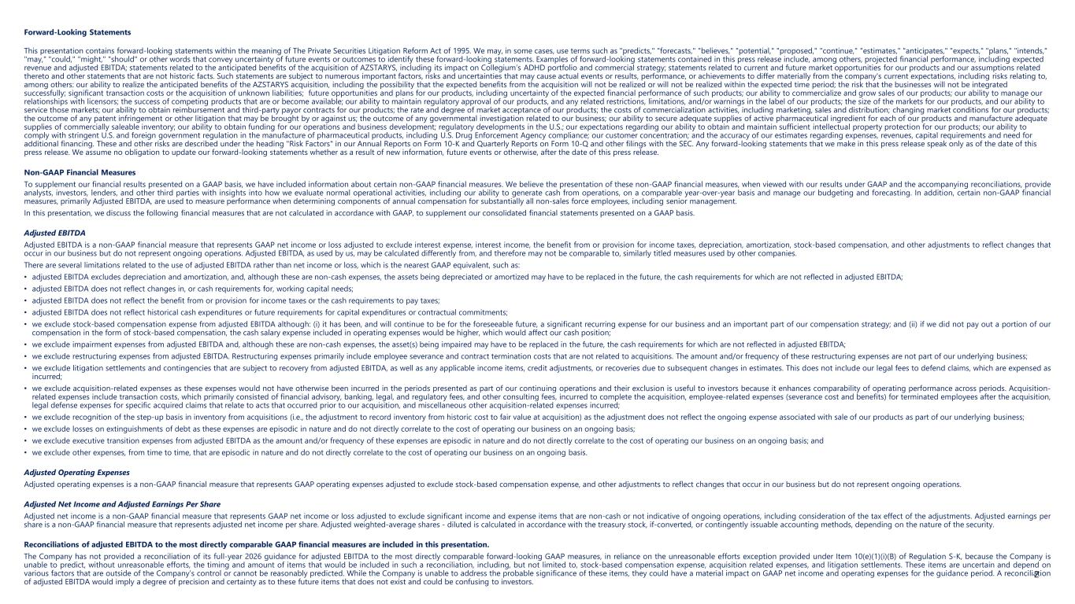
Forward-Looking Statements This presentation contains forward-looking statements within the meaning of The Private Securities Litigation Reform Act of 1995. We may, in some cases, use terms such as "predicts," "forecasts," "believes," "potential," "proposed," "continue," "estimates," "anticipates," "expects," "plans," "intends," "may," "could," "might," "should" or other words that convey uncertainty of future events or outcomes to identify these forward-looking statements. Examples of forward-looking statements contained in this press release include, among others, projected financial performance, including expected revenue and adjusted EBITDA; statements related to the anticipated benefits of the acquisition of AZSTARYS, including its impact on Collegium’s ADHD portfolio and commercial strategy; statements related to current and future market opportunities for our products and our assumptions related thereto and other statements that are not historic facts. Such statements are subject to numerous important factors, risks and uncertainties that may cause actual events or results, performance, or achievements to differ materially from the company's current expectations, including risks relating to, among others: our ability to realize the anticipated benefits of the AZSTARYS acquisition, including the possibility that the expected benefits from the acquisition will not be realized or will not be realized within the expected time period; the risk that the businesses will not be integrated successfully; significant transaction costs or the acquisition of unknown liabilities; future opportunities and plans for our products, including uncertainty of the expected financial performance of such products; our ability to commercialize and grow sales of our products; our ability to manage our relationships with licensors; the success of competing products that are or become available; our ability to maintain regulatory approval of our products, and any related restrictions, limitations, and/or warnings in the label of our products; the size of the markets for our products, and our ability to service those markets; our ability to obtain reimbursement and third-party payor contracts for our products; the rate and degree of market acceptance of our products; the costs of commercialization activities, including marketing, sales and distribution; changing market conditions for our products; the outcome of any patent infringement or other litigation that may be brought by or against us; the outcome of any governmental investigation related to our business; our ability to secure adequate supplies of active pharmaceutical ingredient for each of our products and manufacture adequate supplies of commercially saleable inventory; our ability to obtain funding for our operations and business development; regulatory developments in the U.S.; our expectations regarding our ability to obtain and maintain sufficient intellectual property protection for our products; our ability to comply with stringent U.S. and foreign government regulation in the manufacture of pharmaceutical products, including U.S. Drug Enforcement Agency compliance; our customer concentration; and the accuracy of our estimates regarding expenses, revenues, capital requirements and need for additional financing. These and other risks are described under the heading "Risk Factors" in our Annual Reports on Form 10-K and Quarterly Reports on Form 10-Q and other filings with the SEC. Any forward-looking statements that we make in this press release speak only as of the date of this press release. We assume no obligation to update our forward-looking statements whether as a result of new information, future events or otherwise, after the date of this press release. Non-GAAP Financial Measures To supplement our financial results presented on a GAAP basis, we have included information about certain non-GAAP financial measures. We believe the presentation of these non-GAAP financial measures, when viewed with our results under GAAP and the accompanying reconciliations, provide analysts, investors, lenders, and other third parties with insights into how we evaluate normal operational activities, including our ability to generate cash from operations, on a comparable year-over-year basis and manage our budgeting and forecasting. In addition, certain non-GAAP financial measures, primarily Adjusted EBITDA, are used to measure performance when determining components of annual compensation for substantially all non-sales force employees, including senior management. In this presentation, we discuss the following financial measures that are not calculated in accordance with GAAP, to supplement our consolidated financial statements presented on a GAAP basis. Adjusted EBITDA Adjusted EBITDA is a non-GAAP financial measure that represents GAAP net income or loss adjusted to exclude interest expense, interest income, the benefit from or provision for income taxes, depreciation, amortization, stock-based compensation, and other adjustments to reflect changes that occur in our business but do not represent ongoing operations. Adjusted EBITDA, as used by us, may be calculated differently from, and therefore may not be comparable to, similarly titled measures used by other companies. There are several limitations related to the use of adjusted EBITDA rather than net income or loss, which is the nearest GAAP equivalent, such as: • adjusted EBITDA excludes depreciation and amortization, and, although these are non-cash expenses, the assets being depreciated or amortized may have to be replaced in the future, the cash requirements for which are not reflected in adjusted EBITDA; • adjusted EBITDA does not reflect changes in, or cash requirements for, working capital needs; • adjusted EBITDA does not reflect the benefit from or provision for income taxes or the cash requirements to pay taxes; • adjusted EBITDA does not reflect historical cash expenditures or future requirements for capital expenditures or contractual commitments; • we exclude stock-based compensation expense from adjusted EBITDA although: (i) it has been, and will continue to be for the foreseeable future, a significant recurring expense for our business and an important part of our compensation strategy; and (ii) if we did not pay out a portion of our compensation in the form of stock-based compensation, the cash salary expense included in operating expenses would be higher, which would affect our cash position; • we exclude impairment expenses from adjusted EBITDA and, although these are non-cash expenses, the asset(s) being impaired may have to be replaced in the future, the cash requirements for which are not reflected in adjusted EBITDA; • we exclude restructuring expenses from adjusted EBITDA. Restructuring expenses primarily include employee severance and contract termination costs that are not related to acquisitions. The amount and/or frequency of these restructuring expenses are not part of our underlying business; • we exclude litigation settlements and contingencies that are subject to recovery from adjusted EBITDA, as well as any applicable income items, credit adjustments, or recoveries due to subsequent changes in estimates. This does not include our legal fees to defend claims, which are expensed as incurred; • we exclude acquisition-related expenses as these expenses would not have otherwise been incurred in the periods presented as part of our continuing operations and their exclusion is useful to investors because it enhances comparability of operating performance across periods. Acquisition- related expenses include transaction costs, which primarily consisted of financial advisory, banking, legal, and regulatory fees, and other consulting fees, incurred to complete the acquisition, employee-related expenses (severance cost and benefits) for terminated employees after the acquisition, legal defense expenses for specific acquired claims that relate to acts that occurred prior to our acquisition, and miscellaneous other acquisition-related expenses incurred; • we exclude recognition of the step-up basis in inventory from acquisitions (i.e., the adjustment to record inventory from historic cost to fair value at acquisition) as the adjustment does not reflect the ongoing expense associated with sale of our products as part of our underlying business; • we exclude losses on extinguishments of debt as these expenses are episodic in nature and do not directly correlate to the cost of operating our business on an ongoing basis; • we exclude executive transition expenses from adjusted EBITDA as the amount and/or frequency of these expenses are episodic in nature and do not directly correlate to the cost of operating our business on an ongoing basis; and • we exclude other expenses, from time to time, that are episodic in nature and do not directly correlate to the cost of operating our business on an ongoing basis. Adjusted Operating Expenses Adjusted operating expenses is a non-GAAP financial measure that represents GAAP operating expenses adjusted to exclude stock-based compensation expense, and other adjustments to reflect changes that occur in our business but do not represent ongoing operations. Adjusted Net Income and Adjusted Earnings Per Share Adjusted net income is a non-GAAP financial measure that represents GAAP net income or loss adjusted to exclude significant income and expense items that are non-cash or not indicative of ongoing operations, including consideration of the tax effect of the adjustments. Adjusted earnings per share is a non-GAAP financial measure that represents adjusted net income per share. Adjusted weighted-average shares - diluted is calculated in accordance with the treasury stock, if-converted, or contingently issuable accounting methods, depending on the nature of the security. Reconciliations of adjusted EBITDA to the most directly comparable GAAP financial measures are included in this presentation. The Company has not provided a reconciliation of its full-year 2026 guidance for adjusted EBITDA to the most directly comparable forward-looking GAAP measures, in reliance on the unreasonable efforts exception provided under Item 10(e)(1)(i)(B) of Regulation S-K, because the Company is unable to predict, without unreasonable efforts, the timing and amount of items that would be included in such a reconciliation, including, but not limited to, stock-based compensation expense, acquisition related expenses, and litigation settlements. These items are uncertain and depend on various factors that are outside of the Company’s control or cannot be reasonably predicted. While the Company is unable to address the probable significance of these items, they could have a material impact on GAAP net income and operating expenses for the guidance period. A reconciliation of adjusted EBITDA would imply a degree of precision and certainty as to these future items that does not exist and could be confusing to investors. 2


Business Overview and Commercial Update Vikram Karnani President & Chief Executive Officer

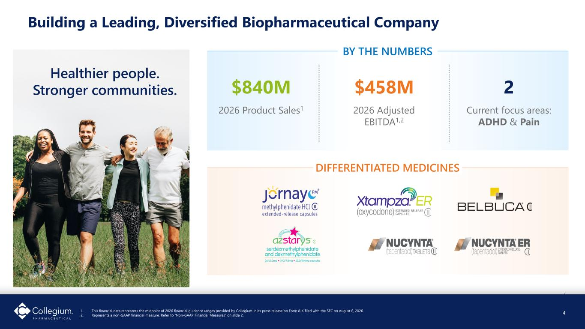
4 Building a Leading, Diversified Biopharmaceutical Company 1. This financial data represents the midpoint of 2026 financial guidance ranges provided by Collegium in its press release on Form 8-K filed with the SEC on August 6, 2026. 2. Represents a non-GAAP financial measure. Refer to “Non-GAAP Financial Measures” on slide 2. Healthier people. Stronger communities. $458M 2026 Adjusted EBITDA1,2 $840M 2026 Product Sales1 2 Current focus areas: ADHD & Pain BY THE NUMBERS DIFFERENTIATED MEDICINES 4

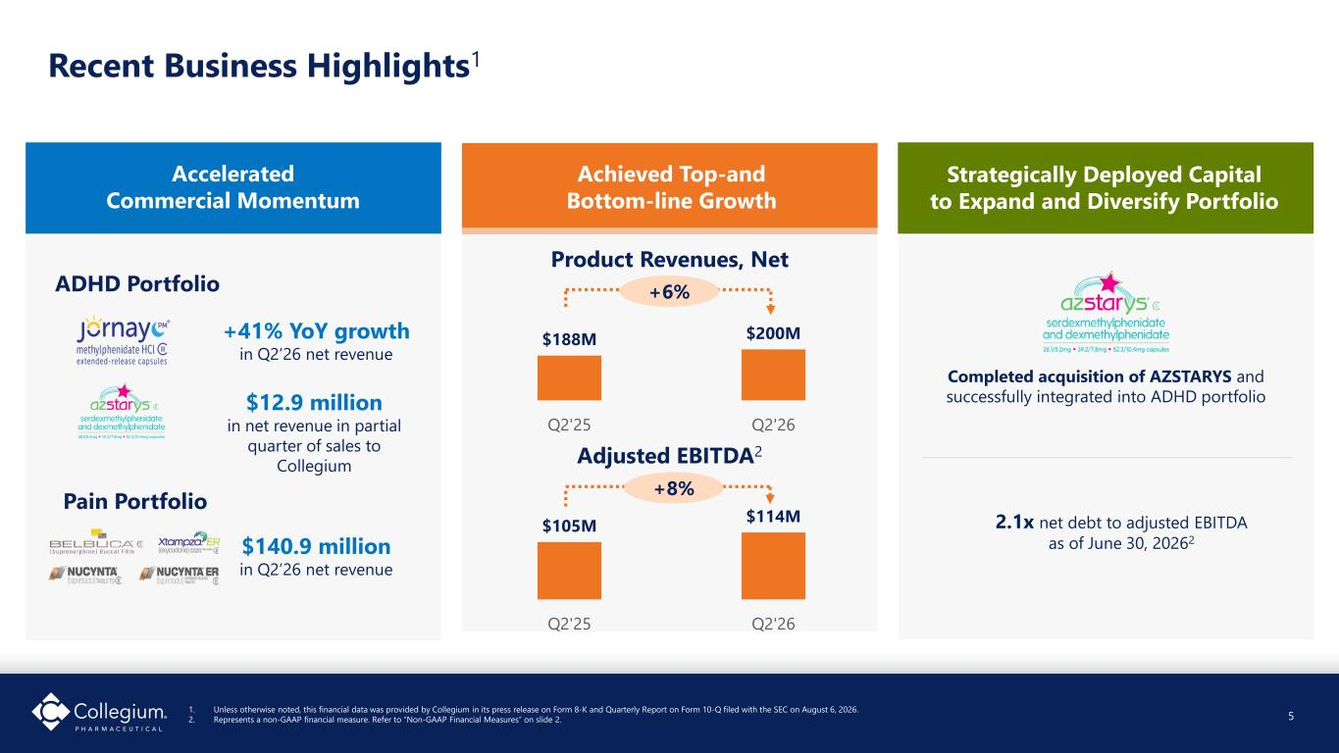
Recent Business Highlights1 1. Unless otherwise noted, this financial data was provided by Collegium in its press release on Form 8-K and Quarterly Report on Form 10-Q filed with the SEC on August 6, 2026. 2. Represents a non-GAAP financial measure. Refer to “Non-GAAP Financial Measures” on slide 2. Accelerated Commercial Momentum Pain Portfolio Strategically Deployed Capital to Expand and Diversify Portfolio 2.1x net debt to adjusted EBITDA as of June 30, 20262 Product Revenues, Net Completed acquisition of AZSTARYS and successfully integrated into ADHD portfolio $188M $200M Q2'25 Q2'26 +41% YoY growth in Q2’26 net revenue $140.9 million in Q2’26 net revenue Achieved Top-and Bottom-line Growth +6% Adjusted EBITDA2 $105M $114M Q2'25 Q2'26 +8% 5 ADHD Portfolio $12.9 million in net revenue in partial quarter of sales to Collegium

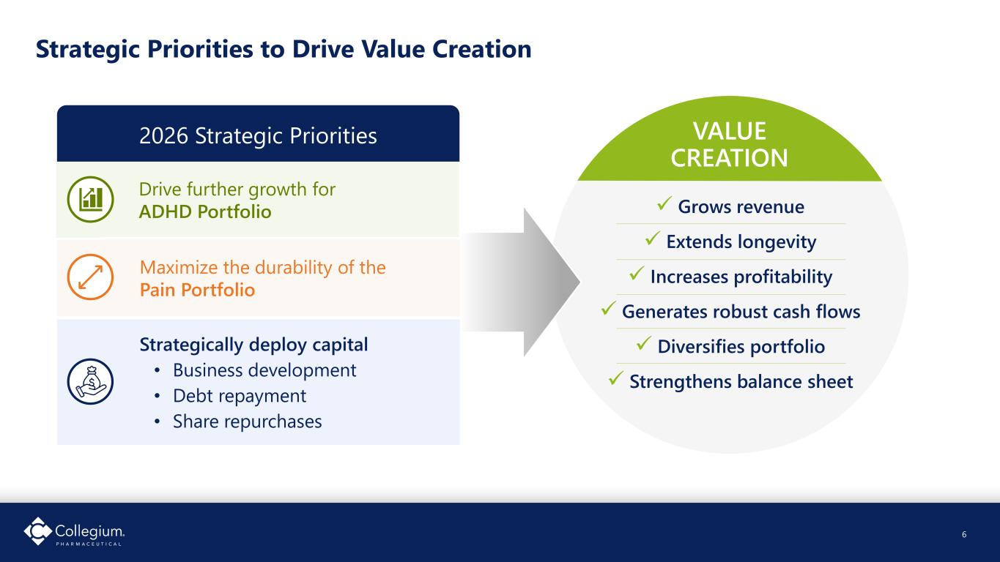
Drive further growth for ADHD Portfolio 6 Strategic Priorities to Drive Value Creation ✓ Grows revenue ✓ Extends longevity ✓ Increases profitability ✓ Generates robust cash flows ✓ Diversifies portfolio ✓ Strengthens balance sheet VALUE CREATION 2026 Strategic Priorities Maximize the durability of the Pain Portfolio Strategically deploy capital • Business development • Debt repayment • Share repurchases 6

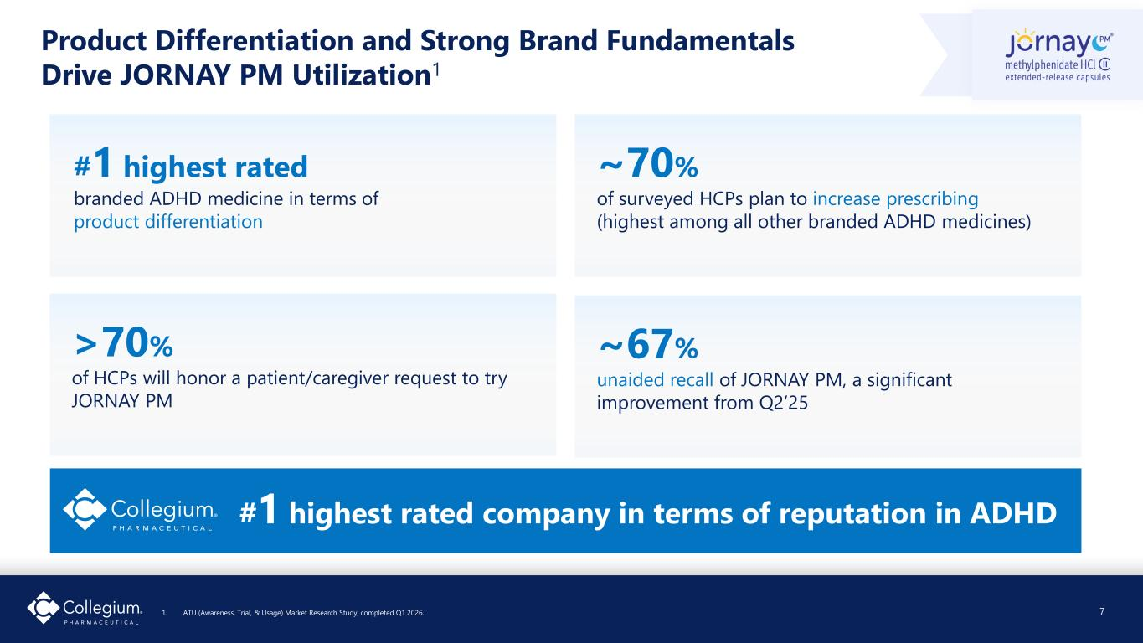
Product Differentiation and Strong Brand Fundamentals Drive JORNAY PM Utilization1 1. ATU (Awareness, Trial, & Usage) Market Research Study, completed Q1 2026. #1 highest rated branded ADHD medicine in terms of product differentiation ~70% of surveyed HCPs plan to increase prescribing (highest among all other branded ADHD medicines) >70% of HCPs will honor a patient/caregiver request to try JORNAY PM ~67% unaided recall of JORNAY PM, a significant improvement from Q2’25 #1 highest rated company in terms of reputation in ADHD 7

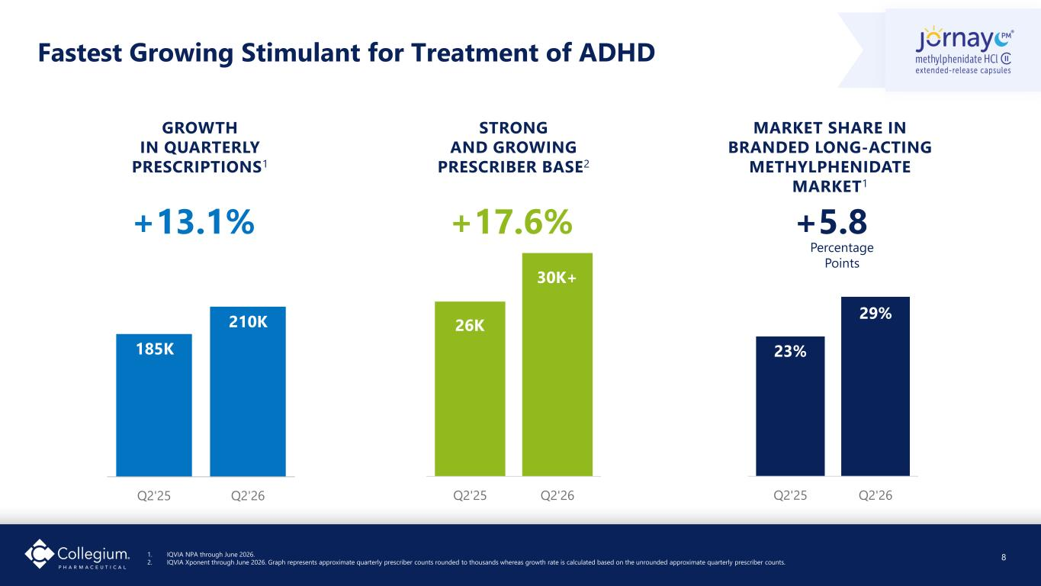
Fastest Growing Stimulant for Treatment of ADHD Q2'25 Q2'26 GROWTH IN QUARTERLY PRESCRIPTIONS1 +13.1% 185K 210K Q2'25 Q2'26 STRONG AND GROWING PRESCRIBER BASE2 +17.6% 26K 30K+ MARKET SHARE IN BRANDED LONG-ACTING METHYLPHENIDATE MARKET1 Q2'25 Q2'26 23% 29% +5.8 Percentage Points 1. IQVIA NPA through June 2026. 2. IQVIA Xponent through June 2026. Graph represents approximate quarterly prescriber counts rounded to thousands whereas growth rate is calculated based on the unrounded approximate quarterly prescriber counts. 8

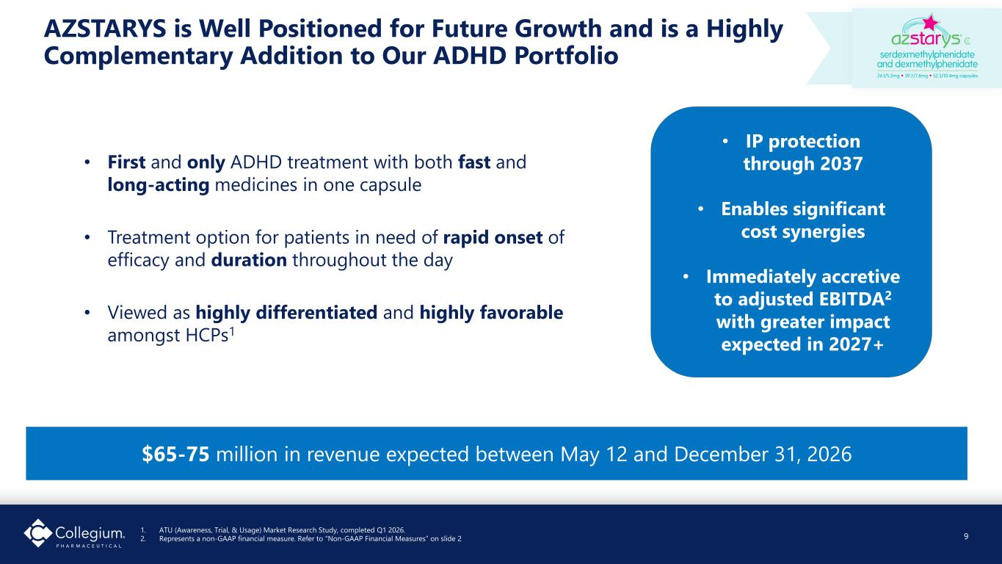
AZSTARYS is Well Positioned for Future Growth and is a Highly Complementary Addition to Our ADHD Portfolio 1. ATU (Awareness, Trial, & Usage) Market Research Study, completed Q1 2026. 2. Represents a non-GAAP financial measure. Refer to “Non-GAAP Financial Measures” on slide 2 • First and only ADHD treatment with both fast and long-acting medicines in one capsule • Treatment option for patients in need of rapid onset of efficacy and duration throughout the day • Viewed as highly differentiated and highly favorable amongst HCPs1 9 $65-75 million in revenue expected between May 12 and December 31, 2026 • IP protection through 2037 • Enables significant cost synergies • Immediately accretive to adjusted EBITDA2 with greater impact expected in 2027+

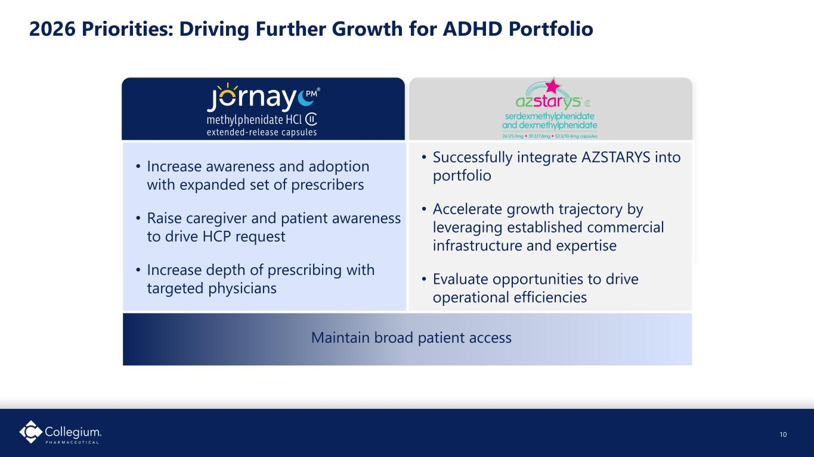
2026 Priorities: Driving Further Growth for ADHD Portfolio • Increase awareness and adoption with expanded set of prescribers • Raise caregiver and patient awareness to drive HCP request • Increase depth of prescribing with targeted physicians • Successfully integrate AZSTARYS into portfolio • Accelerate growth trajectory by leveraging established commercial infrastructure and expertise • Evaluate opportunities to drive operational efficiencies Maintain broad patient access 10

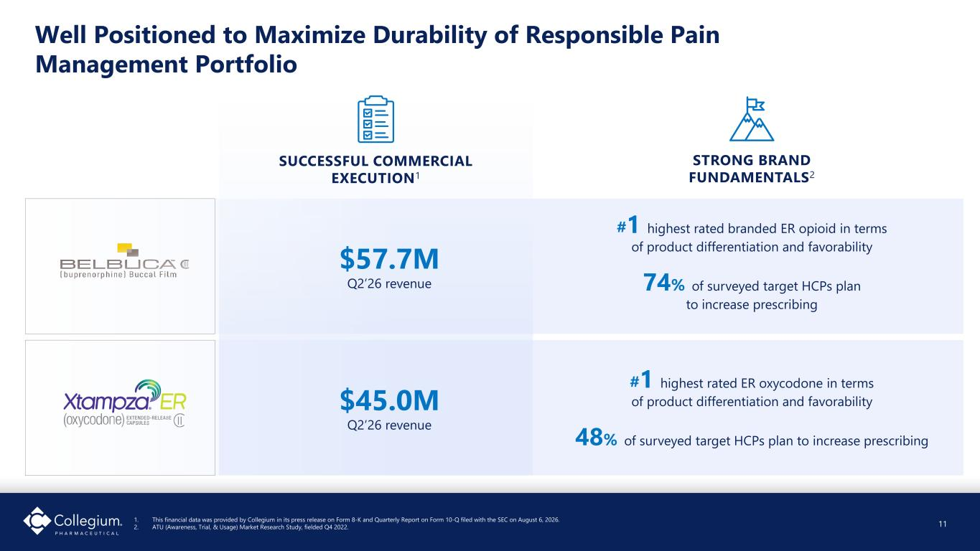
11 Well Positioned to Maximize Durability of Responsible Pain Management Portfolio 1. This financial data was provided by Collegium in its press release on Form 8-K and Quarterly Report on Form 10-Q filed with the SEC on August 6, 2026. 2. ATU (Awareness, Trial, & Usage) Market Research Study, fielded Q4 2022. #1 highest rated branded ER opioid in terms of product differentiation and favorability 74% of surveyed target HCPs plan to increase prescribing STRONG BRAND FUNDAMENTALS2 #1 highest rated ER oxycodone in terms of product differentiation and favorability 48% of surveyed target HCPs plan to increase prescribing SUCCESSFUL COMMERCIAL EXECUTION1 $45.0M Q2’26 revenue $57.7M Q2’26 revenue 11


Financial Highlights Colleen Tupper Executive Vice President & Chief Financial Officer

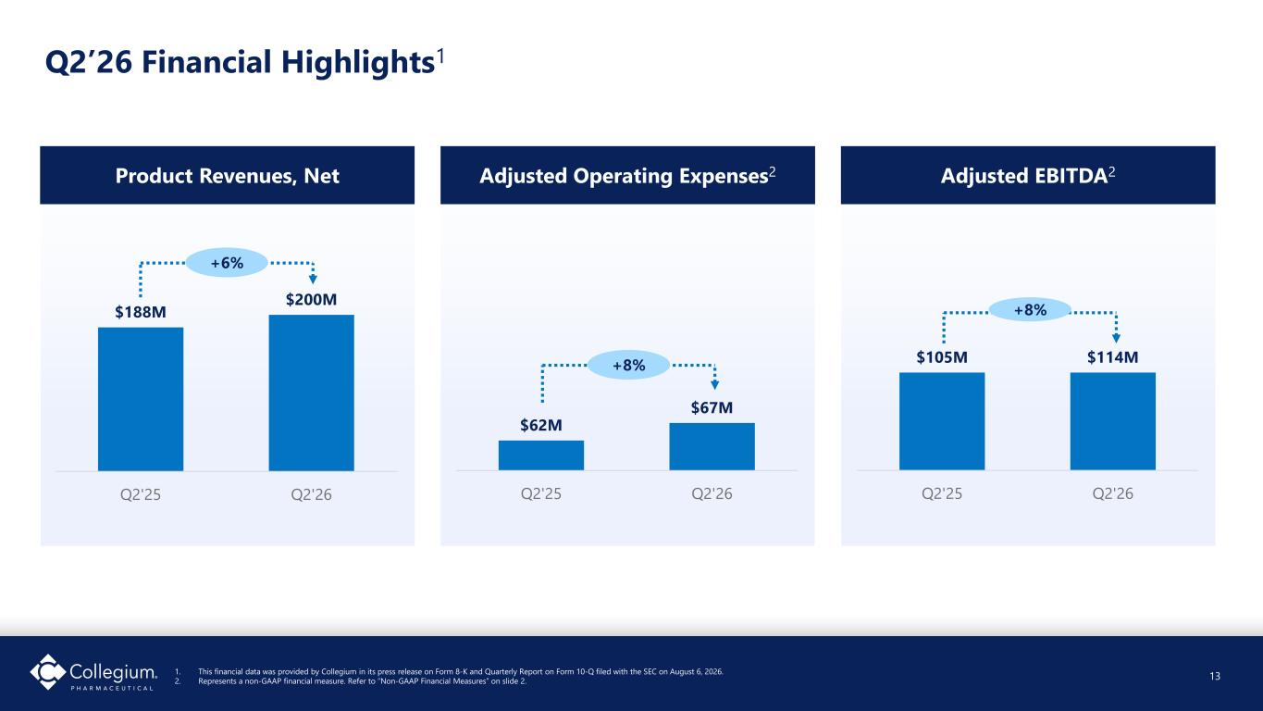
Q2’26 Financial Highlights1 13 1. This financial data was provided by Collegium in its press release on Form 8-K and Quarterly Report on Form 10-Q filed with the SEC on August 6, 2026. 2. Represents a non-GAAP financial measure. Refer to “Non-GAAP Financial Measures” on slide 2. Product Revenues, Net $188M $200M Q2'25 Q2'26 +6% Adjusted Operating Expenses2 $62M $67M Q2'25 Q2'26 Adjusted EBITDA2 $105M $114M Q2'25 Q2'26 +8% +8% 13

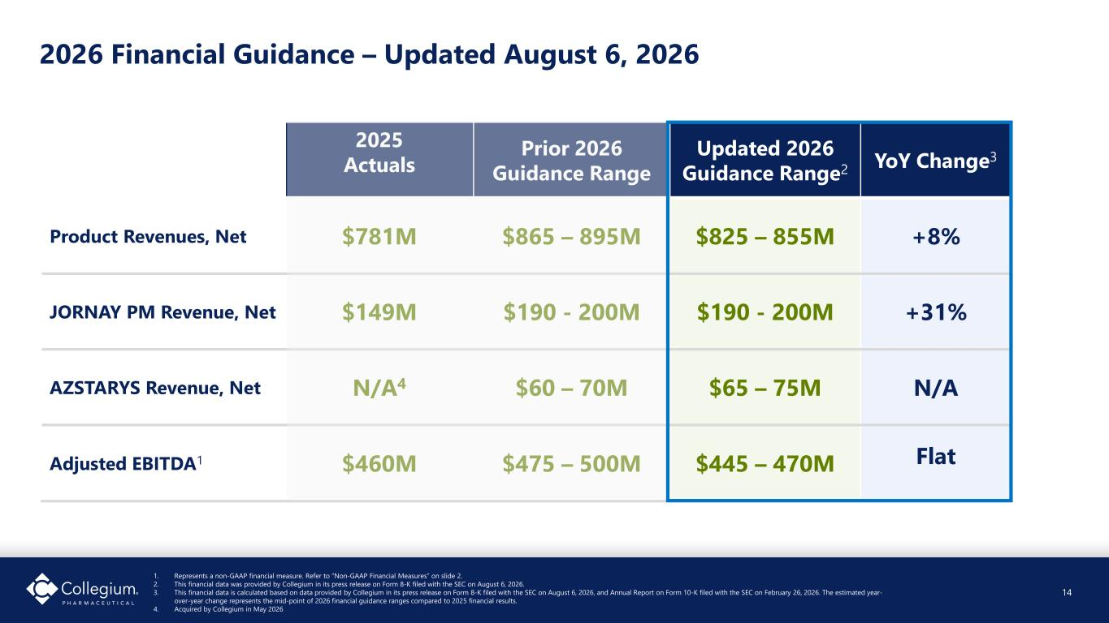
2025 Actuals Prior 2026 Guidance Range Updated 2026 Guidance Range2 YoY Change3 Product Revenues, Net $781M $865 – 895M $825 – 855M +8% JORNAY PM Revenue, Net $149M $190 - 200M $190 - 200M +31% AZSTARYS Revenue, Net N/A4 $60 – 70M $65 – 75M N/A Adjusted EBITDA1 $460M $475 – 500M $445 – 470M Flat 2026 Financial Guidance – Updated August 6, 2026 1. Represents a non-GAAP financial measure. Refer to “Non-GAAP Financial Measures” on slide 2. 2. This financial data was provided by Collegium in its press release on Form 8-K filed with the SEC on August 6, 2026. 3. This financial data is calculated based on data provided by Collegium in its press release on Form 8-K filed with the SEC on August 6, 2026, and Annual Report on Form 10-K filed with the SEC on February 26, 2026. The estimated year- over-year change represents the mid-point of 2026 financial guidance ranges compared to 2025 financial results. 4. Acquired by Collegium in May 2026 14

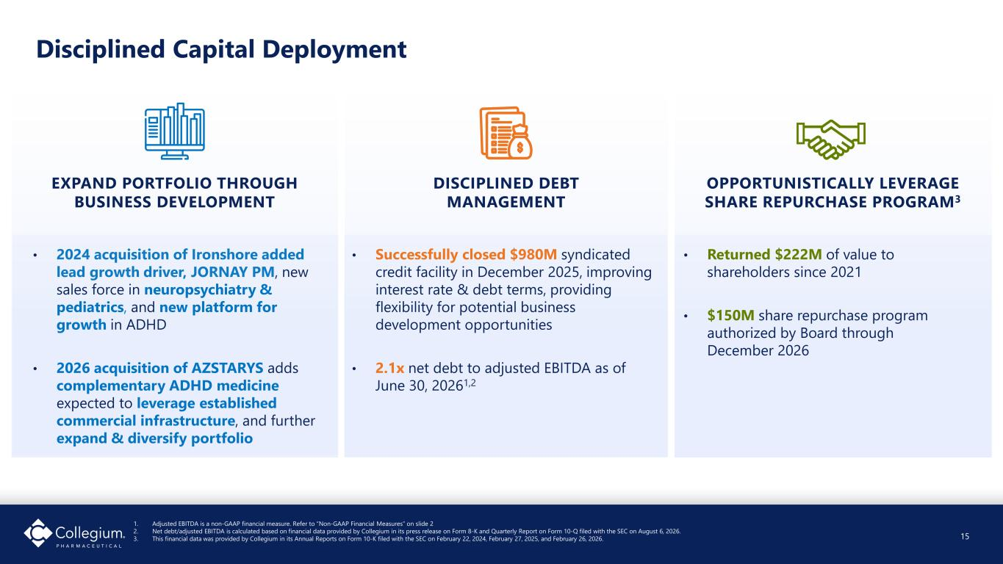
Disciplined Capital Deployment 15 1. Adjusted EBITDA is a non-GAAP financial measure. Refer to “Non-GAAP Financial Measures” on slide 2 2. Net debt/adjusted EBITDA is calculated based on financial data provided by Collegium in its press release on Form 8-K and Quarterly Report on Form 10-Q filed with the SEC on August 6, 2026. 3. This financial data was provided by Collegium in its Annual Reports on Form 10-K filed with the SEC on February 22, 2024, February 27, 2025, and February 26, 2026. EXPAND PORTFOLIO THROUGH BUSINESS DEVELOPMENT • 2024 acquisition of Ironshore added lead growth driver, JORNAY PM, new sales force in neuropsychiatry & pediatrics, and new platform for growth in ADHD • 2026 acquisition of AZSTARYS adds complementary ADHD medicine expected to leverage established commercial infrastructure, and further expand & diversify portfolio OPPORTUNISTICALLY LEVERAGE SHARE REPURCHASE PROGRAM3 • Returned $222M of value to shareholders since 2021 • $150M share repurchase program authorized by Board through December 2026 DISCIPLINED DEBT MANAGEMENT • Successfully closed $980M syndicated credit facility in December 2025, improving interest rate & debt terms, providing flexibility for potential business development opportunities • 2.1x net debt to adjusted EBITDA as of June 30, 20261,2 15


Closing Remarks Vikram Karnani President & Chief Executive Officer

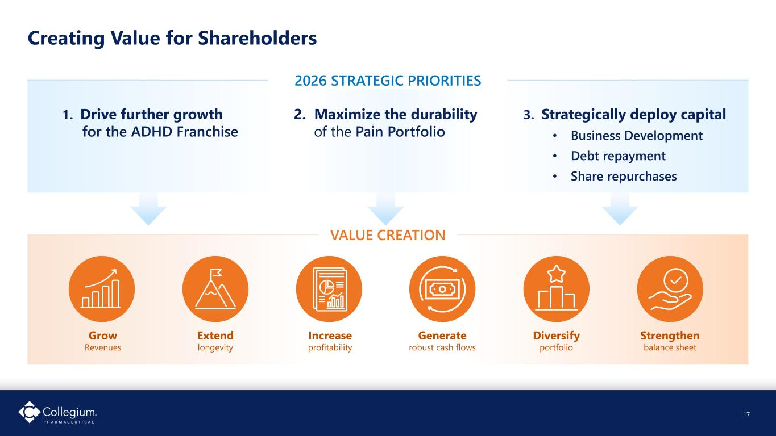
Creating Value for Shareholders 17 2026 STRATEGIC PRIORITIES VALUE CREATION 1. Drive further growth for the ADHD Franchise 2. Maximize the durability of the Pain Portfolio 3. Strategically deploy capital • Business Development • Debt repayment • Share repurchases Grow Revenues Extend longevity Increase profitability Generate robust cash flows Diversify portfolio Strengthen balance sheet 17


18 Healthier people. Stronger communities. A leading biopharmaceutical company focused on improving the lives of people living with serious and often misunderstood conditions 18


Non-GAAP Reconciliations

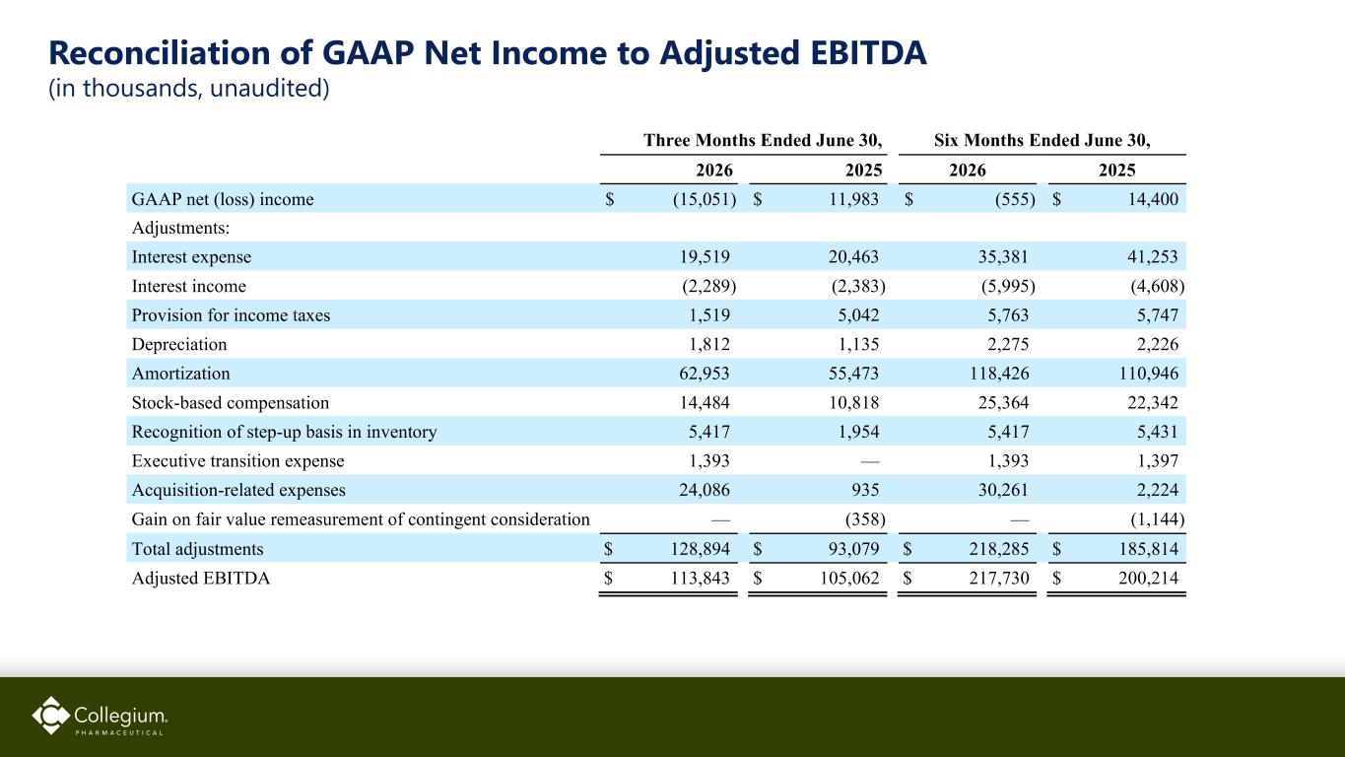
Reconciliation of GAAP Net Income to Adjusted EBITDA (in thousands, unaudited) Three Months Ended June 30, Six Months Ended June 30, 2026 2025 2026 2025 GAAP net (loss) income $ (15,051) $ 11,983 $ (555) $ 14,400 Adjustments: Interest expense 19,519 20,463 35,381 41,253 Interest income (2,289) (2,383) (5,995) (4,608) Provision for income taxes 1,519 5,042 5,763 5,747 Depreciation 1,812 1,135 2,275 2,226 Amortization 62,953 55,473 118,426 110,946 Stock-based compensation 14,484 10,818 25,364 22,342 Recognition of step-up basis in inventory 5,417 1,954 5,417 5,431 Executive transition expense 1,393 — 1,393 1,397 Acquisition-related expenses 24,086 935 30,261 2,224 Gain on fair value remeasurement of contingent consideration — (358) — (1,144) Total adjustments $ 128,894 $ 93,079 $ 218,285 $ 185,814 Adjusted EBITDA $ 113,843 $ 105,062 $ 217,730 $ 200,214

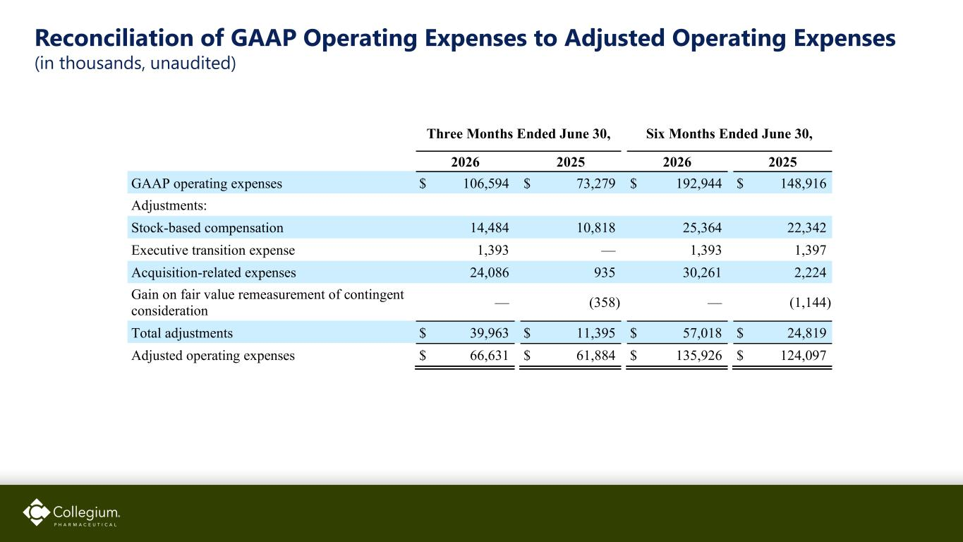
Reconciliation of GAAP Operating Expenses to Adjusted Operating Expenses (in thousands, unaudited) Three Months Ended June 30, Six Months Ended June 30, 2026 2025 2026 2025 GAAP operating expenses $ 106,594 $ 73,279 $ 192,944 $ 148,916 Adjustments: Stock-based compensation 14,484 10,818 25,364 22,342 Executive transition expense 1,393 — 1,393 1,397 Acquisition-related expenses 24,086 935 30,261 2,224 Gain on fair value remeasurement of contingent consideration — (358) — (1,144) Total adjustments $ 39,963 $ 11,395 $ 57,018 $ 24,819 Adjusted operating expenses $ 66,631 $ 61,884 $ 135,926 $ 124,097

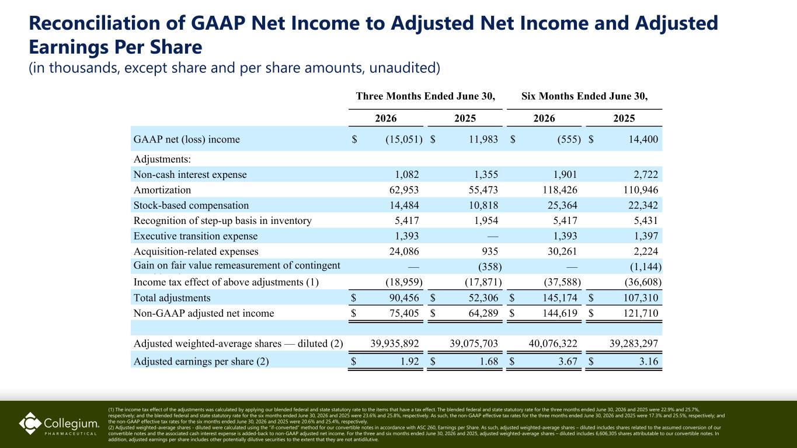
Reconciliation of GAAP Net Income to Adjusted Net Income and Adjusted Earnings Per Share (in thousands, except share and per share amounts, unaudited) (1) The income tax effect of the adjustments was calculated by applying our blended federal and state statutory rate to the items that have a tax effect. The blended federal and state statutory rate for the three months ended June 30, 2026 and 2025 were 22.9% and 25.7%, respectively; and the blended federal and state statutory rate for the six months ended June 30, 2026 and 2025 were 23.6% and 25.8%, respectively. As such, the non-GAAP effective tax rates for the three months ended June 30, 2026 and 2025 were 17.3% and 25.5%, respectively; and the non-GAAP effective tax rates for the six months ended June 30, 2026 and 2025 were 20.6% and 25.4%, respectively. (2) Adjusted weighted-average shares - diluted were calculated using the “if-converted” method for our convertible notes in accordance with ASC 260, Earnings per Share. As such, adjusted weighted-average shares – diluted includes shares related to the assumed conversion of our convertible notes and the associated cash interest expense is added-back to non-GAAP adjusted net income. For the three and six months ended June 30, 2026 and 2025, adjusted weighted-average shares – diluted includes 6,606,305 shares attributable to our convertible notes. In addition, adjusted earnings per share includes other potentially dilutive securities to the extent that they are not antidilutive. Three Months Ended June 30, Six Months Ended June 30, 2026 2025 2026 2025 GAAP net (loss) income $ (15,051) $ 11,983 $ (555) $ 14,400 Adjustments: Non-cash interest expense 1,082 1,355 1,901 2,722 Amortization 62,953 55,473 118,426 110,946 Stock-based compensation 14,484 10,818 25,364 22,342 Recognition of step-up basis in inventory 5,417 1,954 5,417 5,431 Executive transition expense 1,393 — 1,393 1,397 Acquisition-related expenses 24,086 935 30,261 2,224 Gain on fair value remeasurement of contingent id i — (358) — (1,144) Income tax effect of above adjustments (1) (18,959) (17,871) (37,588) (36,608) Total adjustments $ 90,456 $ 52,306 $ 145,174 $ 107,310 Non-GAAP adjusted net income $ 75,405 $ 64,289 $ 144,619 $ 121,710 Adjusted weighted-average shares — diluted (2) 39,935,892 39,075,703 40,076,322 39,283,297 Adjusted earnings per share (2) $ 1.92 $ 1.68 $ 3.67 $ 3.16

